Amenities at 1276 G St, Springfield, OR 97477 Location
Bus Routes: 13, 18, 19
Phone: 541-736-4080
Eight-lane Lap Pool
Lap lanes use circuit swimming to keep traffic flowing. The water is heated to 83 degrees.
Warm Water Pool
This shallow water pool is heated to 88 degrees. It is great for exercising on your own and for lower-intensity water fitness classes.
Deep Water Pool
The deep-water pool, also known as the dive tank, is heated to 83 degrees and is 13 feet deep. It is used for higher-intensity water fitness classes.
Spa
The spa is great for a hot soak after your workout. It is heated to 101 degrees and accessible to people ages 16+ only. Use only in 15-minute increments or less.
Fitness Center
This fitness center offers both strength and cardio equipment including an elliptical, upright bike, recumbent bike, dumbbells, kettlebells, medicine balls, a dip/chin-up/core station, and a plate loaded Smith rack and half-racks.
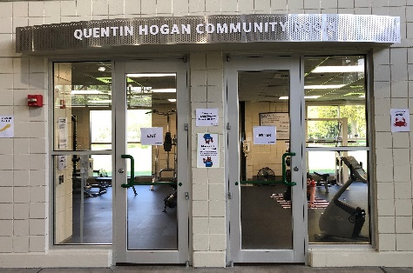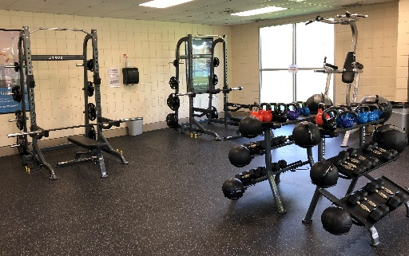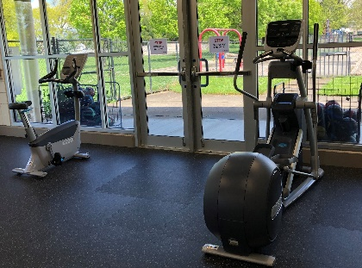

ALL-ACCESS Memberships
As a benefited employee you have FREE access to the All-Access Membership. Sign up at the Bob Keefer Center – 250 S. 32nd Street, Springfield 541-736-4544

Included in Your Membership
- Unlimited access to all our exercise and adult dance classes, including water fitness and virtual classes, taught by outstanding local instructors. Check out this month's schedule.
- Unlimited lap swim and Exercise On Your Own at Willamalane Park Swim Center and Splash! at Lively Park.
- Daily admission to waterpark and recreation swims at both Willamalane Park Swim Center and Splash! at Lively Park.
- Unlimited fitness center use at Bob Keefer Center, including weight training and cardio equipment.
- Unlimited access to the courts at Bob Keefer Center, perfect for pickleball, basketball, and tennis. Call first for availability.
- Unlimited access to bouldering at Bob Keefer Center during regular hours of operation.
- Daily rounds of mini golf at Camp Putt Adventure Golf Park. One round of golf per day, per member. Open seasonally.
- 10% off adult recreation leagues.

Special offers and perks! These offers are subject to change. Your monthly ALL-ACCESS Member newsletter will help you stay in-the-know about monthly special offers and perks for members.

