NOTICE OF PUBLIC HEARING
CITY OF SPRINGFIELD

A PUBLIC HEARING OF THE SPRINGFIELD PLANNING COMMISSION WILL BE HELD ON TUESDAY, OCTOBER 5, 2021 AT 7:00 P.M VIA THE ZOOM ONLINE MEETING PLATFORM TO CONSIDER THE FOLLOWING PROPOSAL:

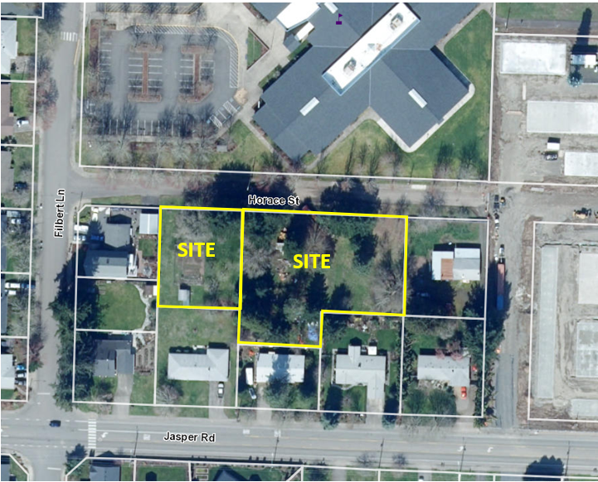
Discretionary Use Application. Applicant seeks approval of the Multi-unit Design Standards – Alternative Design Discretionary Criteria for the proposed multi-unit residential developments on the south side of Horace Street in accordance with the Springfield Development Code (SDC) Section 3.2-240.D.2. The Planning case number for this application is 811-21-000196-TYP3.

The Discretionary Use request affects two parcels zoned Medium Density Residential (MDR), which are located adjacent to each other on the southern side of Horace Street and across from Mt. Vernon Elementary School. These parcels are identified as Assessor’s Map 18-02-05-23, Tax Lot 204 and Assessor’s Map 18-02-05-23, Tax Lot 202. The eastern parcel (Tax Lot 204) is approximately 0.74-acres, and the western parcel (Tax Lot 202) is approximately 0.31 acres for a total of 1.05 acres.

The application, all documents and evidence relied upon by the applicant, the applicable criteria, and the Zoom link are available under the Planning Commission’s October 5th meeting at www.springfieldoregonspeaks.org. They are also available for free inspection at the Development Center within City Hall, 225 Fifth Street, during COVID-19 restricted business hours (8am-Noon & 1pm-4pm) on Tuesdays, Wednesdays, Thursdays, and Fridays. A staff report with the Director’s recommendation will be available 7 days before the hearing both at the Development Center and www.springfieldoregonspeaks.org. Copies of documents are available at a reasonable cost.

Please visit springfieldoregonspeaks.org for information on participating in the online public meeting.

